Group Task Management
Design Document

Authors:
No. | Student ID | Student name
1 | B2303854 | Đặng Chí Trung
2 | B2306547 | Võ Thái Hoàng Khánh
3 | B2306522 | Đoàn Công Danh
4 | B2306516 | Trần Quang Bảo
5 | B2303846 | Triệu Tấn Tài

Group: 5

Document Revision History

Date | Version | Description | Author
10/25/2012 | 0.0 | Initial draft
10/25/2012 | 0.1 | <ex: Added Class Diagram> | John Q. Doe

Contents
1 Introduction 6
1.1 Purpose 6
1.2 System Overview 6
1.3 Design Objectives 6
1.4 References 6
1.5 Definitions, Acronyms, and Abbreviations 6
2 Design Overview 7
2.1 Introduction 7
2.2 Environment Overview 7
2.3 System Architecture 7
2.3.1 Top-level system structure of Fuel level controller 7
2.3.2 Level Monitoring Sub-system 7
2.3.3 Fuel Subsystem 8
2.4 Constraints and Assumptions 8
3 Interfaces and Data Stores 9
3.1 System Interfaces 9
3.1.1 Pressure Sensor Interface 9
3.1.2 Pump Valve Controller Interface 9
3.2 Data Stores 9
4 Structural Design 10
4.1 Design Discussion and Rationale……………………………………………...10
4.2 Class Diagram……………………………………………………………………...11
4.2 Class Descriptions 11
4.3 Classes in the Fuel Subsystem 11
4.3.1 Class: Tank 11
5 Dynamic Model 12
5.1 Scenarios 12
6 Supplementary Documentation 13

Introduction

Purpose
This document describes the software design of the Group Task Management system. Its purpose is to provide a complete and clear design specification so that another development team can implement the system based solely on this document. The document follows the Object-Oriented (OO) Design Template and includes system architecture, structural design, class descriptions, and dynamic behavior models.

System Overview
Group Task Management is a task and project management system that supports team collaboration. The system allows users to manage projects, create and assign tasks, track task progress, receive notifications, and communicate effectively within a team. The target users are students, small teams, and organizations that require structured task coordination.

Design Objectives
The main design objectives of the CWM system are
+ Apply object-oriented design principles
+ Use a multi-layered architecture (UI – Business Logic – Data Access)
+ Achieve low coupling and high cohesion
+.Support extensibility and maintainability
+ Apply appropriate design patterns such as Observer, Factory, and Plugin Architecture
+ Enable future reuse and scalability

References
+ Fundamental of Software Construction, Course Project Specification, Can Tho University, 2025.
+Software Design Description (SDD) Template – English Version, Course Materials..

Definitions, Acronyms, and Abbreviations
UI: User Interface.
BL: Business Logic
DAO: Data Access Object
GTM: Group Task Management

Design Overview

Introduction
The GTM system is designed using an object-oriented approach and follows a multi-layered architecture. UML diagrams such as class diagrams and sequence diagrams are used to model the structure and behavior of the system.

Environment Overview
The system is implemented using Java and runs as a desktop application. Users interact with the system through a graphical user interface. Persistent data is stored in a relational database.

System Architecture

2.3.1 Architectural Overview
The system follows a layered architecture combined with a plugin-based design.
It is organized into three main layers: Presentation Layer, Application Service Layer, and Domain Layer, with an extensible Plugin Layer for notifications.
The architecture aims to:
+Separate user interaction from business logic
+ Improve maintainability and scalability
+ Support extensibility through plugins without modifying core logic.
2.3.2 High-level Block Diagram
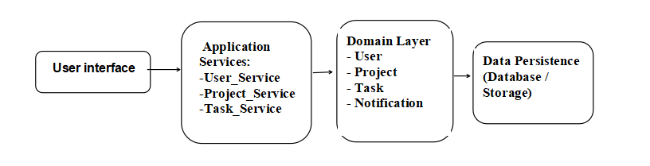

Description:
+ The Presentation Layer handles user input and output.
+ The Application Service Layer contains business logic and system operations.
+ The Domain Layer represents core entities and their relationships.
+ The Data Persistence layer stores system data.

2.3.3 Plugin-based Notification Architecture.
To support extensibility, the system applies a Plugin Architecture for notifications.
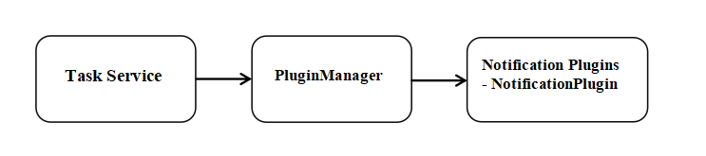
Description:
+ Application services notify the PluginManager when events occur
+ The PluginManager forwards events to all registered plugins
+ Notification behavior can be extended without changing core services

2.3.4 Interaction Overview Diagram
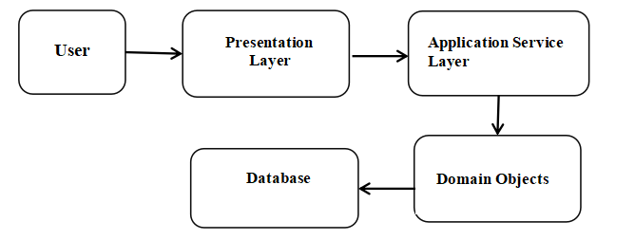This interaction flow illustrates how user actions propagate through system layers.

Constraints and Assumptions

Constraints
The system design is subject to the following constraints derived from the course project requirements:

+ The system must be designed following object-oriented analysis and design principles.
+ The design must conform to the Software Design Description (SDD) Template provided for the course.
+ The system architecture must emphasize modularity, separation of concerns, and reusability.
+ The system must support extensibility through a plugin-based mechanism as required by the project description.
+ The design focuses on logical and conceptual architecture rather than physical deployment or implementation details.
+ Persistent data management is limited to conceptual data storage, without specifying database technologies.
+ The scope of the system is limited to educational project requirements, not commercial-scale deployment.

Assumptions

The following assumptions are made during the design process:
+ Users are assumed to have basic knowledge of using information systems.
+ The system operates within a controlled academic environment.
+ All users access the system through a single application interface.
+ No integration with external systems is required in the current version.
+ Performance and security requirements are assumed to be moderate and suitable for a course project.

Interfaces and Data Stores
This section describes the interfaces into and out of the system as well as the data stores you will be including in your system.

System Interfaces
The various interfaces provided to users and/or other external systems should be defined here. If you had included user interface descriptions in your requirements document you may refer to them here. If you provide interfaces to other systems, say export and import data to a different software, you should mention them here.
Do not include JavaDocs here. You should describe the interfaces using prose and graphics if your interface includes a GUI.
The following is provided as an example:

Pressure Sensor Interface
This interface is used to measure the liquid pressure at the bottom of the tank from which the fuel level is computed. The sensor measures pressure in pounds per square inch (psi). A hardware interface is provided to access the sensor reading from the Controller software. The data can be accessed by the software at a fixed memory location (using memory mapped I/O).

Pump Valve Controller Interface
Description goes here…

Data Stores
Describe the internal databases/data stores you will create AS PART OF YOUR SYSTEM – any data permanently stored on the hard drive. This should NOT include databases or other data stores that are external to your system. This information should be included in a previous section.

Structural Design

Design Explanation and Rationale

A written explanation of the design you chose, explaining how your system is structured, how requests are handled, and how communication and control flow through your system.

This section should also include design justification, including specific rationale for the decisions made in the design (for example, why your design may be better than another or why you chose to implement a specific design pattern in one of your subsystems).

Class Diagram
The following class diagram illustrates the system architecture, adhering to the
Multi-layered principles and incorporating specific entities to handle project management, task delegation, and automated notifications.
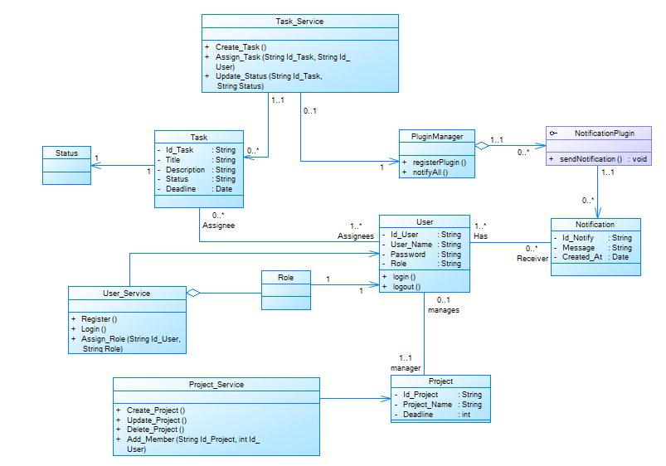

Class Descriptions
In this section you would describe in detail each class, its attributes, and its methods. You should logically group classes together. For example, you may use your architecture diagrams to group classes within a sub-system together.
Provide a subsection for each class. For each class, briefly describe its purpose, any constraints, (e.g., only single instance) and list the attributes and the methods of each class in the class diagram.
For each class, describe each of its attributes with the following details: name, type, a one line description of the attribute if its meaning is not intuitive, and constraints on the attribute (e.g., attribute must have unique value for each object or value range is restricted to positive integers).
Each method should be described with the following details: method name, return type and value, parameters, purpose and a brief description of the algorithm used (if it is non-trivial). Pre-conditions and post-conditions should be mentioned here if there are any assumptions about the arguments or the return values. List the attributes read and modified by this method and other methods invoked by this method.
The following is provided as an example:

Classes in the Fuel Subsystem

Class: <User>
- Purpose: Represents a system user, managing authentication and authorization levels.
- Constraints:
- Each instance must be assigned a valid role (Admin, Manager, Member).
- A user can act as a manager for at most one project.
- Persistent: Yes

Attribute Descriptions
- Attribute: Id_User
Type: String
Description: Unique identifier for the user account.
Constraints: Must have a unique value for each object; cannot be null.

2. Attribute: User_Name
Type: String
Description: The account name used for system login.
Constraints: Must be unique; typically restricted to alphanumeric characters.

3. Attribute: Password
Type: String
Description: Encrypted string used for user authentication.
Constraints: Must be encrypted before storage for security compliance.

4. Attribute: Role
Type: String
Description: Defines the user's authorization level (Admin, Manager, Member).
Constraints: Value range is restricted to the set {Admin, Manager, Member}.

Method Descriptions
1. Method: login()
Return Type: boolean
Parameters: None
Return value: True if credentials are valid; false otherwise.
Pre-condition: User must provide User_Name and Password.
Post-condition: A session is created if the return value is true.
Attributes read/used: User_Name, Password.
Methods called: None.

Processing logic:
The method compares the provided input against the stored User_Name and the decrypted Password.

Test case 1:
Verify that a user with the correct role "Manager" can access project settings while a "Member" cannot.

2. Method: logout()
Return Type: void
Parameters: None
Return value: N/A
Pre-condition: An active user session must exist.
Post-condition: The current session is terminated, and the user is redirected to the login screen.
Attributes read/used: Id_User.
Methods called: None.

Processing logic:
Clears all session tokens and local cache related to the Id_User.

Test case:

Class: < Project >
- Purpose: Handles the business logic for project lifecycle management, including creation, modification, and member assignment.
- Constraints:
- Represents a collaborative project entity within the system, storing its core data and timeframe.
- Persistent: No

Class: < Project_Service >
- Purpose: To assign a specific user to a project, granting them access to the project's tasks and resources.
- Constraints:
- Only users with the "Manager" or "Admin" role can invoke project modification methods.
- The system must enforce that the Deadline is strictly after the Start Date.
- Ensures that Id_Project and Project_Name do not duplicate existing records in the database.
- Each project is restricted to a single primary Manager
- Persistent: No

4.4.3.1 Method Descriptions
1. Method: Create_Project()
Return Type: void
Parameters: String Project_Name, Date Start_Date, Date Deadline
Return value: N/A
Pre-condition: The user must be authenticated and hold a "Manager" or "Admin" role.
Post-condition: A new Project entity is instantiated, validated, and saved to the persistent storage.
Attributes read/used: Project_Name, Deadline.
Methods called: Data Access methods for saving records..

Processing logic:
The method validates that the Deadline is chronologically after the Start_Date. It also checks if the Project_Name already exists to prevent duplicates. If all constraints are met, it instantiates a new Project object and saves it to the database.

Test case:
Verify that providing a Deadline earlier than the Start_Date results in a validation error and no project is created.

2. Method: Update_Project()
Return Type: boolean
Parameters: String Id_Project, String newName, Date newDeadline
Return value: True if the update is successful; False otherwise.
Pre-condition: The project with Id_Project must exist in the system.
Post-condition: The project's metadata is updated in the persistent storage.
Attributes read/used: Id_Project, Project_Name, Deadline.
Methods called:

Processing logic:
The method retrieves the existing project, applies the new values, and re-validates the temporal constraint.

Test case:
Verify that an Admin can successfully change a project's name and that the changes are reflected in the database.

3. Method: Add_Member()
Return Type: void
Parameters: String Id_Project, String Id_User
Return value: N/A
Pre-condition:
- The Id_Project must exist in the system.
- The Id_User must exist and hold a valid account.
Post-condition: Both Id_Project and Id_User must exist in the database.
Attributes read/used: Id_Project, Id_User.
Methods called: Data Access methods for saving records..

Processing logic:
The method retrieves the user and project objects. It checks if the user is already assigned to the project to avoid duplicates. If the user is eligible, it creates a link in the project membership table.

Test case:
Verify that a "Member" added to a project can now be seen in the project's contributor list and is assigned the "Assignee" relationship.

4. Method: Delete_Project()
Return Type: boolean
Parameters: String Id_Project
Return value: True if the project is successfully removed; False if the project does not exist or a database error occurs.
Pre-condition:
- The Id_Project must exist in the system.
- The current user must have "Admin" or "Manager" authorization.
Post-condition:
- The project record is permanently removed from the database.
- All associated tasks related to this project are also deleted
Attributes read/used: Id_Project
Methods called: Data Access methods for saving records..

Processing logic:
- Step 1: The system identifies the project using the provided Id_Project.
- Step 2: It verifies the user's permissions to ensure they are authorized to perform a deletion.
- Step 3: To maintain data integrity, the method first triggers a cascade deletion of all tasks linked to this project.
- Step 4: Finally, it removes the project entry from the database and returns a success status.

Test case:
Using JUnit, create a test project with several tasks, then invoke Delete_Project(). Verify that the project is no longer found in the database and that the task count for that project ID is zero.

Class: < Project_Service >
- Purpose: Represents a specific unit of work or an activity that needs to be completed within a project.
- Constraints:
- A task must always be associated with a parent Project.
- The Deadline of a task cannot exceed the Deadline of its parent Project.
- Persistent: Yes

Attribute Descriptions
1. Attribute: Id_Task
Type: String
Description: Unique identifier for each task.
Constraints: Must be Unique and Non-null.

2. Attribute: Title
Type: String
Description: A short name or summary of the task.
Constraints: Cannot be empty.

3. Attribute: Description
Type: String
Description: Detailed information, instructions, or requirements for the task.

4. Attribute: Status
Type: String
Description: The current progress stage of the task.
Constraints: Values are restricted to the set: {To Do, In Progress, Done, Cancel}.

5. Attribute: Deadline
Type: Date
Description: The specific date and time by which the task must be completed.
Constraints: Must be chronologically after the creation date and before the Project's end date.

    - Class: < Task_Service>
- Purpose: Manages the business logic for task-related operations, including creation, status tracking, and delegation, acting as a bridge between the UI and Task entities.
- Constraints:
- Methods must be verified via JUnit to ensure functional reliability.
- Adheres to the Template Method design pattern for consistent processing flows.
- Persistent: No

      - Method Descriptions
1. Method: Create_Task()
Return Type: void
Parameters: String Title, String Description, Date Deadline
Return value: void
Pre-condition: A valid Project must be selected, and the user must have "Manager" or "Admin" permissions.
Post-condition: A new Task record is instantiated and saved to the database.
Attributes read/used: Title, Description, Deadline.
Methods called: Data Access methods for saving records..

Processing logic:
The system validates that the task's Deadline falls within the timeframe of the parent Project. If valid, it assigns a unique Id_Task and persists the object.

Test case:
Verify that a task cannot be created with a deadline that exceeds the project's overall end date.

2. Method: Assign_Task()
Return Type: void
Parameters: String Id_Task, String Id_User
Return value: N/A
Pre-condition: The user is linked to the task as an "Assignee".
Attributes read/used: Id_Task, Id_User.
Methods called: Data Access methods for saving records..

Processing logic:
The system retrieves the User and Task objects. It establishes a link in the assignment table, allowing the user to view and update the task.

Test case:
Confirm that a user assigned to a task receives access to that task's details in their dashboard.

3. Method: Update_Status()
Purpose: To modify the current lifecycle stage of a task and trigger notifications.
Return Type: void
Parameters: String Id_Task, String Status
Return value: N/A
Pre-condition: The Id_Task must be valid, and the new Status must be within the set {To Do, In Progress, Done, Cancel}.
Attributes read/used: Id_Task, Status.
Methods called: Data Access methods for saving records..

Processing logic:
The system updates the Status attribute of the identified task. Once updated, it invokes the Observer Pattern via the PluginManager to alert team members of the progress change.

Test case:
Using JUnit, change a task's status to "Done" and verify that a Notification object is generated with the correct timestamp.

    - Class: < User_Service>
- Purpose: Manages the core logic for user accounts, including registration, authentication, and the assignment of system roles.
- Constraints:
- Passwords must be hashed/encrypted before being passed to the data layer.
- Only an Admin can invoke the Assign_Role method to modify user permissions.
- Persistent: No

      - Method Descriptions
1. Method: Register()
Return Type: boolean
Parameters: String User_Name, String Password
Return value: True if the account is successfully created; False if the username already exists.
Pre-condition: The provided User_Name must not be empty.
Post-condition: A new User record is created in the database with a default role (usually "Member").
Attributes read/used: User_Name, Password.
Methods called: Data Access methods for saving records..

Processing logic:
The system checks the database to ensure the User_Name is unique. If unique, it encrypts the Password and creates a new User entity.

Test case:
Use JUnit to verify that registering with an existing username returns false.

2. Method: Login()
Return Type: boolean
Parameters: String User_Name, String Password
Return value: True if credentials match; False otherwise.
Pre-condition: None.
Post-condition: An active session is established for the user if successful.
Attributes read/used: User_Name, Password.
Methods called: Data Access methods for saving records..

Processing logic:
The method retrieves the stored user data and compares the provided password with the encrypted password in the database.

Test case:
Verify that a user with incorrect credentials cannot access the system.

3. Method: Assign_Role()
Return Type: void
Parameters: String Id_User, String Role
Return value: N/A
Pre-condition: To change the authorization level of a specific user.
Post-condition: The current operator must have "Admin" privileges.
Attributes read/used: Id_User, Role..
Methods called: Data Access methods for saving records..

Processing logic:
Validates the existence of the user and ensures the new Role value belongs to the allowed set {Admin, Manager, Member}.

Test case:
Verify that a "Member" role is successfully upgraded to "Manager" by an Admin.

    - Class: < PluginManager>
- Purpose: Acts as the "Subject" in the Observer Pattern, managing the registration and execution of various notification plugins to alert users of system events.
- Constraints:
- Only one instance of the PluginManager should exist during the system's runtime.
- It must remain independent of the specific notification logic used by the plugins.
- Persistent: No

      - Method Descriptions
1. Method: registerPlugin()
Purpose: To add a new notification plugin to the manager's active list.
Return Type: boolean
Parameters: NotificationPlugin plugin
Return value: N/A
Pre-condition: The plugin object must implement the NotificationPlugin interface.
Post-condition: The plugin is added to the internal collection of observers.
Attributes read/used: Internal list of plugins.
Methods called: None

Processing logic:
The method receives a plugin instance and stores it in an internal list. This allows the system to be extensible without changing the core code.

Test case:
Using JUnit, verify that after calling registerPlugin(), the internal list size increases and contains the added plugin.

2. Method: notifyAll()
Purpose: To trigger the notification process across all registered plugins simultaneously.
Return Type: void
Parameters: None.
Return value: N/A
Pre-condition: At least one plugin must be registered for a notification to be sent..
Post-condition: All registered plugins execute their specific notification logic.
Attributes read/used: Internal list of plugins.
Methods called: Data Access methods for saving records..

Processing logic:
The method iterates through every plugin in the internal list. For each plugin, it calls the sendNotification() method. This ensures that when a task status changes, all alert channels are activated.

Test case:
Mock a plugin and verify that when notifyAll() is called by Task_Service, the plugin's sendNotification() method is executed exactly once.

    - Class: < NotificationPlugin> (interface)
- Purpose: Defines a common contract for all notification types.

      - Method Descriptions
1. Method: sendNotification()
Purpose: Abstract method that concrete plugins (like EmailPlugin) must implement to deliver the actual message.
Return Type: void

    - Class: < Notification>
- Purpose: Represents an alert or message generated by the system to inform users about specific events.
- Constraints:
- Each notification must be linked to a specific Receiver .
- The Message content must not be null or empty.
- Persistent: Yes

Attribute Descriptions
1. Attribute: Id_Notify
Type: String
Description: Unique system-generated identifier for the notification entry.
Constraints: Must be Unique and Non-null.

2. Attribute: Message
Type: String
Description: The descriptive text of the alert (e.g., "Project 'Alpha' has been updated").
Constraints: Typically limited to 255 characters for storage efficiency.

3. Attribute: Created_At
Type: Date
Description: The timestamp indicating exactly when the notification was triggered.
Constraints: Automatically generated by the system at the moment of instantiation.

Dynamic Model

Scenarios
This section describes the dynamic behavior of the system through typical usage scenarios.
Each scenario illustrates how system components interact over time in response to user actions.

Scenario: User Login

Description: This sequence diagram describes the sequence of actions that take place when a user logs into the system.
Sequence of Actions:

The User enters username and password.
- The system receives the login request.
- The system validates the credentials.
- The system creates a user session.
- The system returns the login result to the user.

Sequence Diagram:
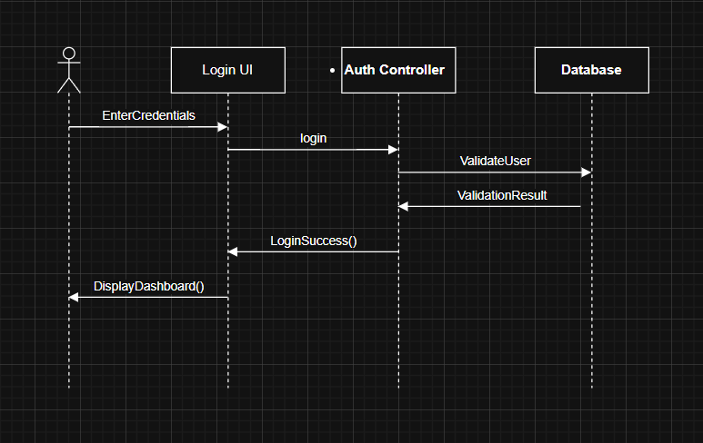

Scenorio : View Task

Description:This scenario describes how a logged-in user views assigned tasks.
The user requests to view task information, and the system retrieves task data from the database and displays it.
Sequence of Actions:
- The User selects the “View Task” function.
- The system verifies that the user is authenticated.
- The system sends a request to retrieve task data.
- The database returns the list of tasks.
- The system displays task details to the user.
Squence Diagram:
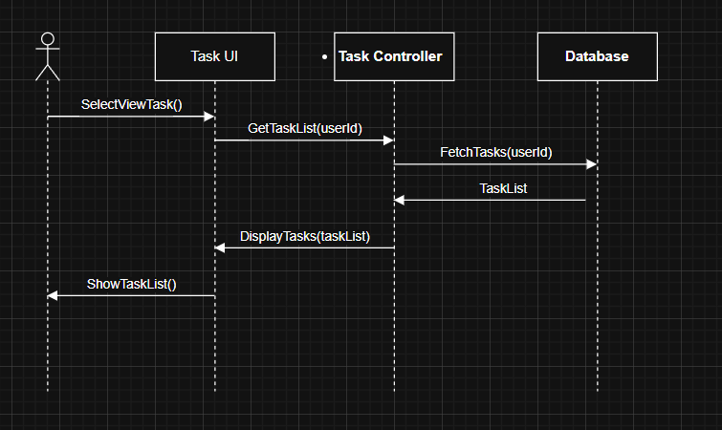

Scenario: Update Task Status
Description:This scenario describes how a user updates the status of a task.
After updating, the system sends a notification.
Sequence of Actions:
- The User selects a task to update.
- The User chooses a new task status.
- The system validates the update request.
- The system updates the task status in the database.
- The system includes the “Send Notification” use case to notify related members.
- The system confirms the update to the user.
Sequence Diagram:

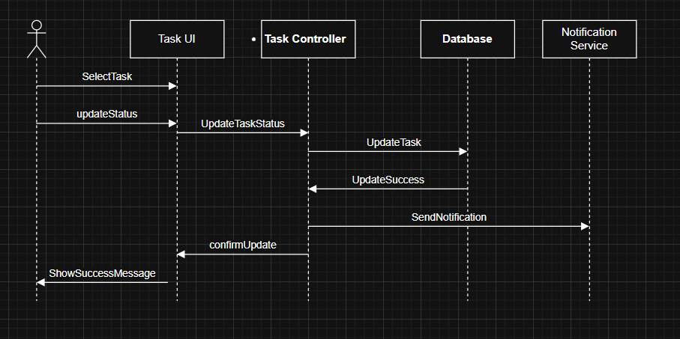

Scenario: Create Project

Scenario Description:
This scenario describes how a manager creates a new project in the system.
The system records the project information and prepares it for further management activities.
Sequence of Actions:
- The Manager selects the “Create Project” function.
- The system checks the manager’s authorization.
- The Manager enters project details.
- The system validates the input data.
- The system stores the project information in the database.
- The system confirms successful project creation.
Sequence Diagram:
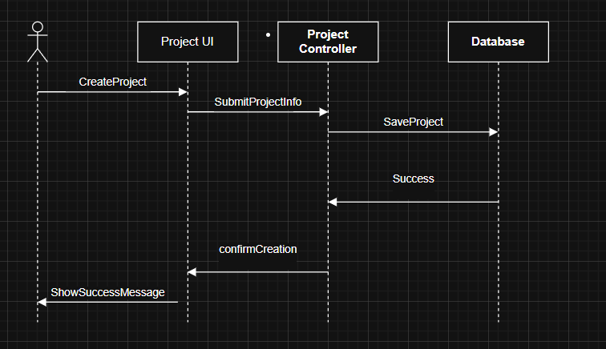

5.1.5 Scenario: Add Member to Project

Scenario Description
This scenario describes the sequence of actions that take place when a Manager adds a user as a member to an existing project.
After the member is successfully added, the system automatically sends a notification to the related user.
This behavior is mandatory because the Add Member use case includes the Send Notification use case.
Sequence of Actions:
- The Manager selects the Add Member function on the project management interface.
- The Project UI sends the add member request to the Project Service, including the project identifier and user identifier.
- The Project Service validates the manager’s permission and checks whether the user is already a member of the project.
- The Project Service stores the project–member relationship in the Database.
- The Database confirms that the member has been successfully added.
- The Project Service invokes the Notification Service to send a notification to the added member.
- The Notification Service processes the event and confirms that the notification has been sent.
- The Project Service returns a success result to the Project UI.
- The Project UI displays a confirmation message to the Manager.
Sequene Diagram:
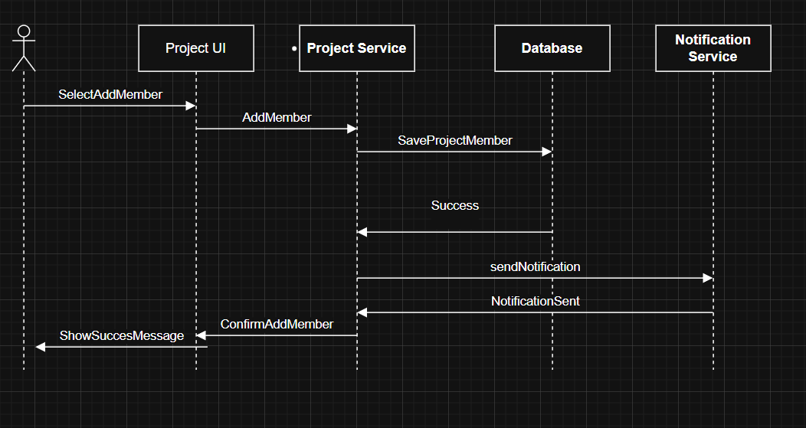

5.1.6 cenario: Create Task

Scenario Description
This scenario describes the sequence of actions that take place when a Manager creates a new task within an existing project.
The system validates the task information, ensures that project constraints are satisfied, and stores the task in persistent storage.
This scenario focuses only on task creation and does not include task assignment.
Sequence of Actions:
- The Manager selects an existing project and chooses the Create Task function.
- The Manager enters task information, including title, description, and deadline.
- The Task UI sends the task creation request to the Task Service.
- The Task Service validates the task information and checks that the deadline is within the project timeframe.
- The Task Service stores the new task in the Database.
- The Database confirms that the task has been successfully created.
- The Task Service returns a success response to the Task UI.
- The Task UI displays a confirmation message to the Manager.
Sequence Diagram:
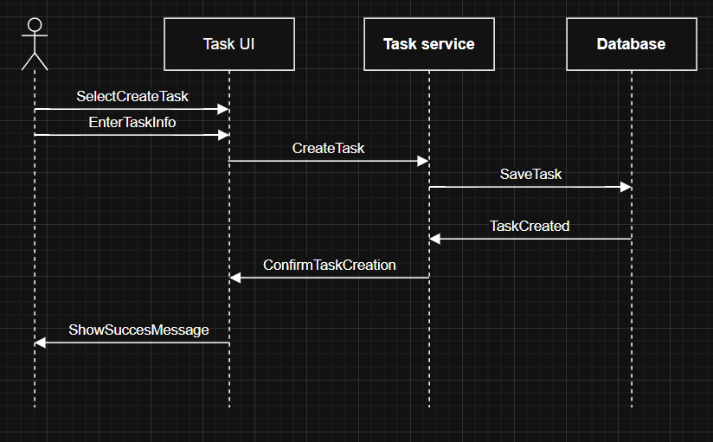

Supplementary Documentation
Provide any other relevant documentation that may help understanding the design.

